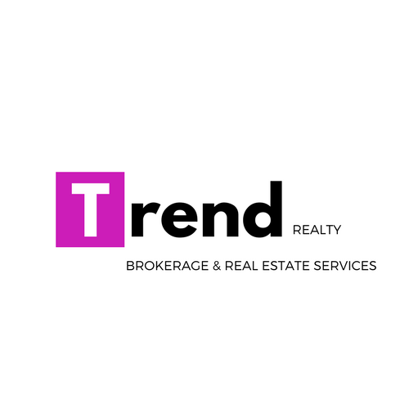

Trend Prestige Package (Leads):

• 70/30 Split & 50/50 Split on Provided Leads - LOW Monthly Membership
• Personalized For Sale Sign
• Personalized Name Badge
• First Run of Business Cards
• Custom Website with fully integrated IDX & CRM
• Centrally Located Sarasota & Fort Myers Locations
• 2 Full SERVICE Brokers with over 30 years of combined experience
• Ongoing Comprehensive Sales training
• Survival Guide and Business Plan - A proven path to success
• Customized Marketing Materials with Lending Partner
• Social Media Expert on Staff
• Transaction Desk File Review & Management
• Trend Realty Training Facebook Group for Networking, Videos and Questions
• Get paid @ closing, with our CDA program
• E & O insurance on transactions
• Just $399/transaction (training, technology and transaction review)
*Consumer Compliance Fees Apply
Many 100% commission companies are not interested in NEW licensees. At Trend, we enjoy working with both experienced AND newly licensed agents.

Trend Pro Package:

• 100% Commission - LOW Monthly Membership
• Centrally Located Sarasota & Fort Myers Locations
• 2 Full SERVICE Brokers with over 30 years of combined experience
• Survival Guide and Business Plan - A proven path to success
• Customized Marketing Materials with Lending Partner
• Social Media Expert on Staff
• Transaction Desk File Review & Management
• Trend Realty Training Facebook Group for Networking, Videos and Questions
• Get paid @ closing, with our CDA program
• E & O insurance on transactions
• Just $399/transaction (training, technology and transaction review)
*Consumer Compliance Fees Apply
Many 100% commission companies are not interested in NEW licensees. At Trend, we enjoy working with both experienced AND newly licensed agents.

